**Amazon like Customer View – Challenge #1**

**Products for Sale Table.**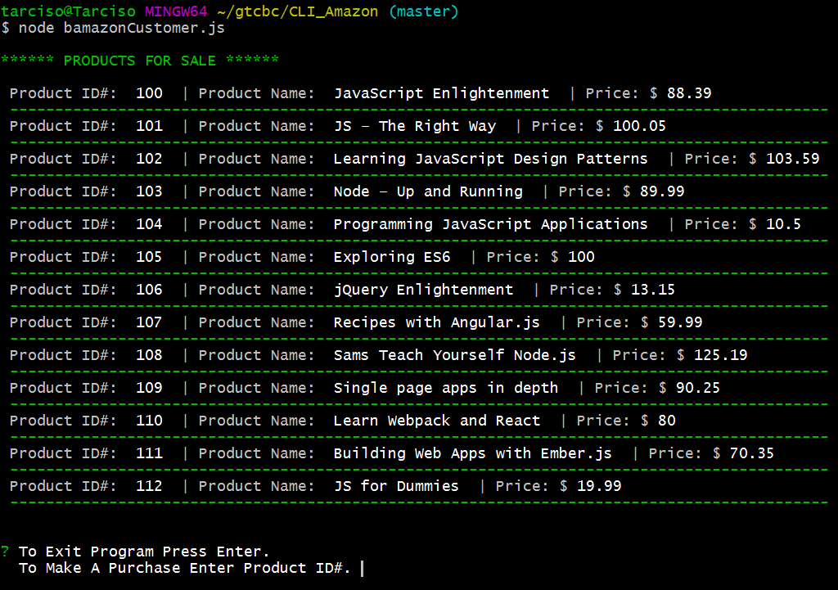

**Selecting and adding to cart. Total = quantity * product price.**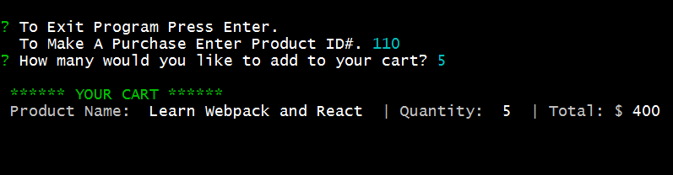

**By pressing enter it will exit the program.**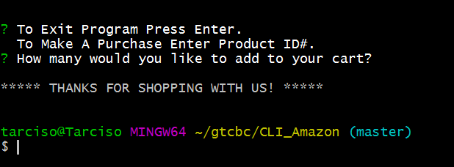

**If user missed an input, it will prompt if user wish to exit program.**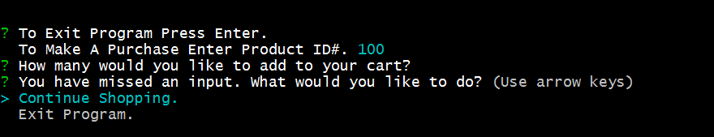

**By choosing Exit it will disconnect from database e exit the program. Otherwise user could wish to go back to main menu.**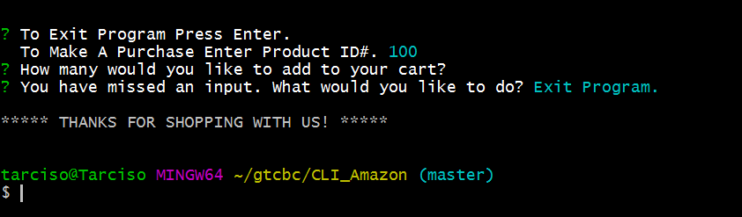

**If quantity to purchase is higher than the one available in stock, Error prevent from load of database wrongfully. It will show quantity available.**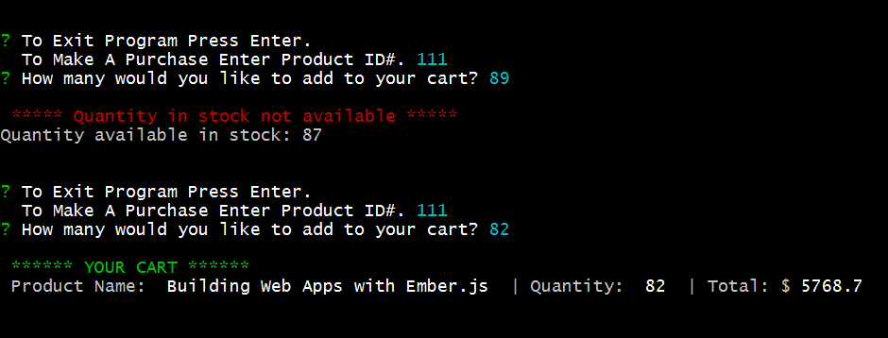

**Amazon like Manager View – Challenge #2**

**Manager Main Menu view.**

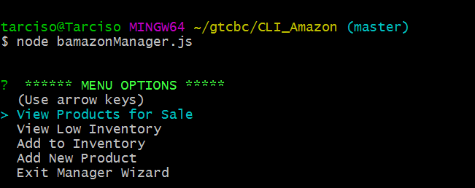

**Products view for sale and its stock**

